8th July 2013

**YOKOHAMA Supports Environmental Preservation at Laojun Mountain, Yunnan Province, China**

Tokyo - The Yokohama Rubber Co., Ltd., announced today that Yokohama Rubber (China) Co., Ltd., the holding company for its operations in China, is supporting environmental protection activities – described as “agriculture development and evolution” – that were launched in Heyuan, an ethnic minority village in the Laojun Mountain Nature Reserve in Lijiang, Yunnan Province, China. The activities are being implemented as part of a project for sustainable growth and ecological preservation in the Heyuan community conducted by a Chinese environmental NGO, the Beijing SanSheng Environment and Development Research Institute. A ceremony in June to commence the effort was attended by Chairman and President Koichi Tanaka of Yokohama Rubber (China) and employees, who donated beekeeping equipment to the villagers.

In the Lijiang region, economic development is being activated by tourism, etc., even as deforestation, poaching and so on is threatening the natural ecosystem. The project for sustainable growth and ecological preservation in the Heyuan community at Laojun Mountain was begun in 2011 with the aim of helping establish an economic system in which the villagers could earn a living while preserving the natural ecosystem. In support of this, in July 2012, Yokohama Rubber (China) Co., Ltd. began a project to support education tied to ecological protection in Heyuan. Now, in addition, the company has begun supporting beekeeping, planting tenma, which grows naturally in the area.

In November 2005, Yokohama Rubber (China) Co., Ltd., was established in the city of Shanghai as a holding company to exercise overall control of its tire and multiple-business (MB) operations in China. In its "Medium-range Management Plan: Grand Design 100 (GD100)," the Yokohama Rubber Group vows to assert “world-class strengths in technologies for protecting the environment.” Among other things, Yokohama Rubber’s sales and production subsidiaries in China have also carried out tree plantings under the Yokohama Forever Forest Project.

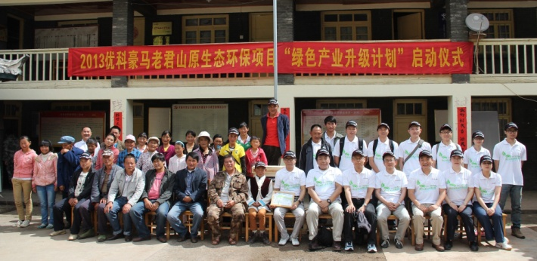

*Participants at the ceremony in June*